**Sequence Diagrams for the Address Book Example**

Each of the use cases discovered in the analysis of the system will be realized by a sequence of operations involving the various objects comprising the system.

* Sequence Diagram Realizing the Add a Person Use Case
* Sequence Diagram Realizing the Edit a Person Use Case
* Sequence Diagram Realizing the Delete a Person Use Case
* Sequence Diagram Realizing the Sort Entries by Name Use Case
* Sequence Diagram Realizing the Sort Entries by ZIP Use Case
* Sequence Diagram Realizing the Print Entries Use Case
* Sequence Diagram Realizing the Create New Address Book Use Case
* Sequence Diagram Realizing the Open Existing Address Book Use Case
* Sequence Diagram Realizing the Save Address Book Use Case
* Sequence Diagram Realizing the Save Address Book As ... Use Case
* Sequence Diagram Realizing the Offer to Save Changes Extension

# Add a Person Use Case Sequence Diagram

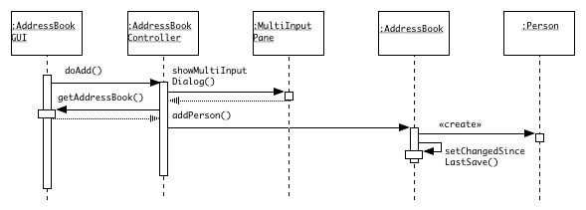

# Edit a Person Use Case Sequence Diagram

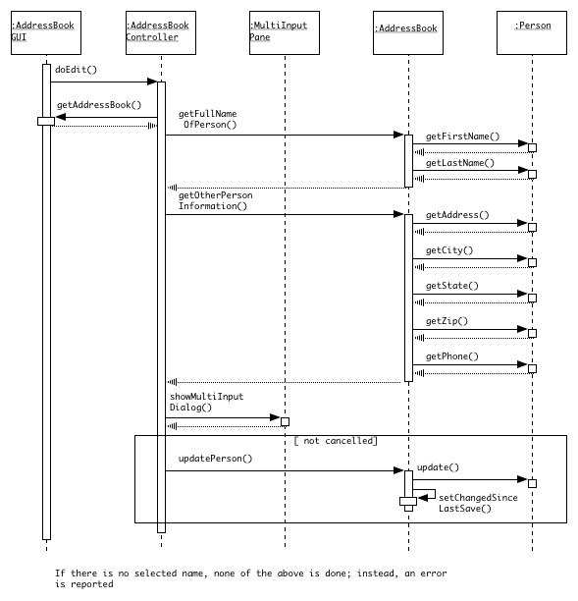

# Delete a Person Use Case Sequence Diagram

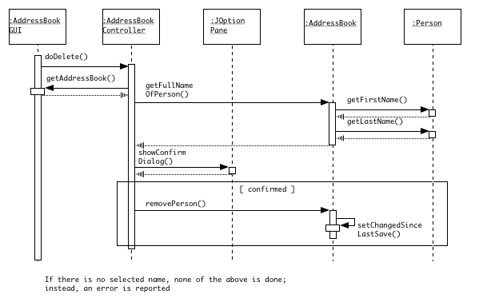

# Sort Entries By Name Use Case Sequence Diagram

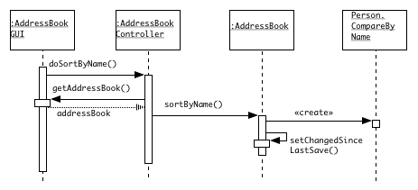

# Sort Entries By Zip Use Case Sequence Diagram

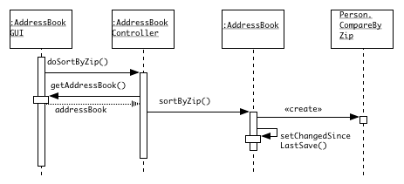

# Print Entries Use Case Sequence Diagram

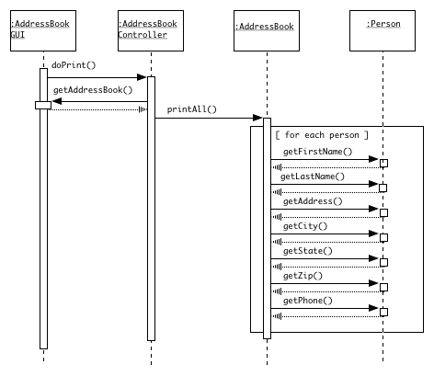

# Create New Address Book Use Case Sequence Diagram

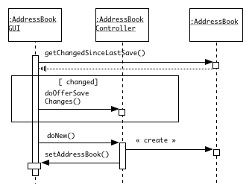

# Open Existing Address Book Use Case Sequence Diagram

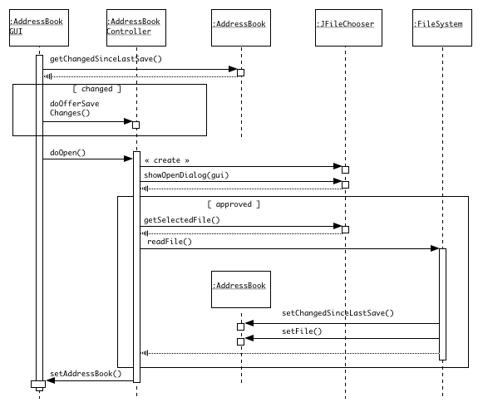

# Save Address Book Use Case Sequence Diagram

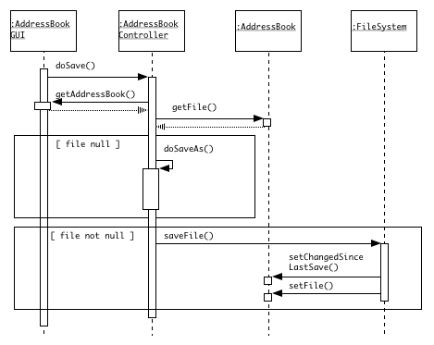

# Save Address Book As ... Use Case Sequence Diagram

## The Sequence Diagram for the Save Address Book As ... Use Case is left as an exercise

# Offer To Save Changes Extension Use Case

